DocNo: 001.E.1:1

Bug Tracking
User’s Guide
Version 2.0

By:
Twister Group
2003-07

Group Member:
Bob
Jalin
Mario
Roger
Minerva

Document Language:
English

Revision History
Date | Version | Description | Author
<02/08/2003> | <1.0> | 1st edition | Twister
<12/08/2003> | <2.0> | Revised edition | Roger and Minerva
Final date | <x.x> | <details> | <name>
Key Word
BTS
Bug
User’s guide
Operation
Function
Digest
This document tells how to use BTS system. Together with manual, any new users of BTS will have a clear picture of function in BTS and master this system easily.

1Introduction 4
1. 1Purpose 4
1. 2Background 4
1. 3Definition 4
1. 4Reference 4
2Usage 4
2. 1Function 4
2.2Performance 6
2.2.1 Precision 6
2.2.2Time-Concerned Character 6
2.2.3Flexibility 6
2. 3Security 6
3. System Requirement 7
3.1Hardware 7
3.2Supporting Software 7
3.3DataStructure 7
4During Using 8
4.1Installation and Initiate 8
4.2Input 8
4.2.1Input Data Background 8
4.2.2Input Format 10
4.2.3Instance For Inputting 11
4.3Output 12
4.3.1Output Data Background 12
4.3.2Output Format 14
4.3.3Instance For Output 14
4.4Query Document 15
4.5Exception Management 15
4.6Terminal Operations 15

1Introduction

1Purpose
This book is written for the users of BTS (Bug Tracking System), it will describe the system in detail and help every user to understand the function of this computer-aimed bug management system well.

2Background
This system initially names as Bug Tracking System, short for BTS. The task presenter of this project is Twister team, while the developer is also Twister team, and the supervisor department is the software college of Shanghai Jiao Tong University. The design phase references Lunar-Linux tracker of lunar penguin team and BMS of Wicresoft Company. And we prefer this net-based software will help your software develop team works more effectively and efficiently.

3Definition
BTS: Bug Tracking System
SJTU: Shanghai Jiao Tong University
Twister: Our Develop Team
User’s guide: to guide users how to use BTS and understand the function of this system
Usage: the function and purpose of this system
Run-time environment: The basic running condition of hardware or software for BTS

4Reference
Wicrosoft “BMS White Cover Book”

2Usage

1Function
    - Project Initial
When a project initiate, the administrator will define the attribute of this project, but all this attribute can be modified later.
    - Project Edit
After a project created, some information can be added to it and some of the information can be modified.
    - Project Close
When the life circle of the project come to an end, the project must be closed by administrate manually. After project closing, no bug can be reported any longer. And some report of the project will be generated as soon as the project was closed.
    - Bug Reporting
The first step of the main function, the users should report the bug he found in his project and let along all the other things to the BTS to manage that bug.
    - Bug Edit
When a bug was reported, fixed or verified, some of its information should be modified, so the user use this function to accomplish the tasks.
    - Bug Query
In out BTS, the user can not only report a bug, but track the bugs as well, by querying the specific bug, the software developer can found the bug he want easily so that to know the current state of the bug.
    - Bug Statistic Report
As a project manager or the team leader, he should know how this project going, so he need some statistics to control this all. BTS provide such functions to give a clear picture of the whole project according to the various condition combination.
    - Specialty
      - Project attribute design
The administrator can initiate a project and set all the attributes such as personnel, project span est. and then the system will manage the bug found in this project automatically.
      - Project personnel chosen
We have a friendly interface for our users, we get the staff information from the existing company information database, the user can choose the person he want and add to our BTS, remember: one person should be added to the system only once.
      - Tasks assign(authority management)
When a bug is reported, the assign to attribute define the responser, but chances are that some testers have not the authority to assign tasks, out system solve this problem as follows, we will leave the bug “assign to” attribute as blank and set its state as schedule, and than the project manager will deal with this case.
      - Bug severity alert
When a user do a query or statistics, the result set is a list of required bugs, we provide a specialty that the color of the bug will be different according to its severity.
      - Bug priority show
When a user do a query or statistics, the result set is a list of required bugs, we provide a specialty that if the bug in urgent, there will be a tag aside the bug title, so that the users will understand which one should be deal with first.
      - Bug Statistics report preference design
As we all know, there are all kinds of statistics report, then which one is our user need? Different users want different information. We design a specialty that let our users their selves make their condition according to their requirement.

2.2Performance

2.2.1 Precision
Our BTS system was a correct one firstly, he can found all the bugs related to the specific project and track the bug status changing. Further more, we offer a authority management system, it will help the manager to control this project. The user will be defined as different authority according to his role. For instance, the project manager (maybe named as team leader in BTS as well) may have the authority of assign tasks, edit project attributes all other advanced power, while the junior tester may only have the report bug authority.

2.2.2Time-Concerned Character
The software architecture decides its performance. We build this Bug Tracking System on a well-designed architecture, we use J2EE design patterns like: front controller, service locater and command. So our BTS will run on application sever effectively, more than 500 user can access to our site synchronously.

2.2.3Flexibility
We fully consider our users when designing this BTS, so this BTS will suit most of the software development company. First, we got staff information from the existing company information system, so it will avoid the inconsequence. Then, we can custom our roles for each project, which enable the users to naming preference. We can call project manager as team leader as you wish. Additionally, the statistics condition combinations also show our system flexibility. Different reports will be made according to the different condition combinations.

3Security
The BTS is secure because we design an authority system for it. Different role will have different authority. That enable the orders in the team, the junior tester will not have advanced authority like edit project information like a project manager, so that the system can manage the software developing phase correctly and effectively.3Run-time Environment

3. System Requirement

3.1Hardware
The minimize hardware configuration for running BTS is as below:
  - CPU: Pentium 500Hz or above (Pentium 866 recommended)
  - Memory: 256M or above (512M recommended)
  - Hard Disk: 1G or above (2G recommended)
  - Adopt TCP/IP

3.2Supporting Software
In order to run BTS, the following software and their versions are required:
  - Windows 98/2000/XP (Windows 2000 Server/Windows 2003 is recommended)
  - IBM Websphere (Version 5.0)
  - IBM DB2 (Version 8.1)
  - Client PCs should have JAVA environments

3.3DataStructure
BTS needs IBM DB2 (Version 8.1) to act as database.
The data volume to support BTS is Stuff Information, thus the customer software enterprise shall provide Stuff Information System as external system to give data BTS needs.

4During Using

4.1Installation and Initiate
Before installation, we need to do the following preparing:
- The DB2 must have been installed on the server.
- Java environment must have been installed on the server. (We strongly recommend IBM Websphere)
- The DB2 must be always on running.
- The free space in hard disk is large enough.
After that, we can start our installation BTS:
- Insert the installation disk.
- Run the file “Setup”
- Carefully look at the software installation guide.
- Follow the installation guide to install the software.
- After all the install steps, check “finish” to over the installation.
BTS is easy to installed. If the users follow the guide, there will be no problems in setup. If you come across the problem you can’t deal with, please report it to us.

After installation, you can do something to initiate:
- Test the connection between BTS and database.
- Check and start the server
- Create several projects in BTS (optional).
- Define the project’s roles and their authorities (optional).

4.2Input

4.2.1Input Data Background
The main input data backgrounds is as below”
- Situation:
  - Create Project:
      - When a new project needs to use the BTS, the administrator ought to create a project and input the necessary information of project.
      - The input frequency is random, only there are new projects, the input occurs.
      - All the input tasks are completed by admin.
  - Edit Project:
      - When the administrator needs to modify the project., he input the edit information to the project.
      - The input frequency is random, only when the admin is told to modify the project.
      - All the data input tasks are done by admin.
  - Bug Specific:
      - When the tester finds bugs, he ought to specific the bug.
      - The input frequency is random, only when the tester finds bug and report it.
      - All the data input tasks are completed by tester.
  - Edit Bug:
      - When the bug is transmit to tester, PM, programmer, they use their authorities to edit bug status.
      - The input occurs when a bug is transmitted from person A to person B, and person B has done his work and modified the bug status.
  - Query Bugs:
      - When the user wants to look at certain bugs, the may use query subsystem to query bugs. At this time, he shall input the requirements of the query. BTS search the database, and return the qualified bugs to user.
      - The input occurs at any times when use wants to query bugs.
  - Statistic:
      - When PM or tester or programmer wants to view the statistic information, they enter the statistic requirements to BTS, the BTS searches the qualified items and shows to the user.
      - The input may occur at any times when the users want to have statistic, but they may have different statistic scope because of their different authorities.
- Frequency of situation
Refer to part a, at each situation.
- Input Medium
We use the keyboard and mouse to complete all the input work. Keyboard is used to input data and information, while mouse is used to select some requirement and complete control work.
- Confine
From the factor of security, any access to the data of BTS will be authorized. Any user shall log on the system BTS first, and then he may have input authorities.
Different people have different security level, generally, PM is relatively high and programmer and tester is low.
- Quality Management
In order to prevent user inputting error information, we must check the data user input, we use the JavaScript to check the basic information at client side and carefully check at server side. It means we can decrease the possibility of having fatal errors.
When the input is error, the information will be displayed to the users, the operation will be denied.
- Dominate
When user input data, the data will be treated at different ways. In the cases of creating project, editing project, specific bug and editing bug, the data will be saved to the database if there is no error. The input data won’t be saved when user statistic bug.
In the bug life cycle, we can see bug have some status, different users are responsible for different status. When users complete their tasks, they must edit the bug status. The data will be transmitted to other users.

4.2.2Input Format
We have some confines for the input format:
- Length:
Project name/Bug name: less than 50 characters.
Date: Year/Month/Day (e.g. 2003/1/1)
Project description/Bug description: less than 150 characters.

- Format Standard:
BTS doesn’t force user to follow the format standard. But we recommend some format standards:
    - All the input data shall keep with the left of text field, without any blank.
    - The data in the text field shall be composed of alphabet, digit and some usual symbols. Don’t input some unusual symbols.
    - The length of data shall not beyond the constraint.
    - All the input shall truly reflect the information of projects or bugs in real world.
- Grade Symbol:
When we specify bug, we can define bug with different levels:
  - We divide the bug priority into 5 levels, level 5 is the highest and level 1 is the lowest.
  - We divide the bug severity into 4 levels, level 4 is the highest and level 1 is the lowest.
  - The query and statistic scope is divided into Personal scope and Organization scope.
While we specify the role or the bug, we use this symbol to define the priority, severity or query scope, statistic scope.
- Sequence:
User shall not care about the sequence of data, because BTS has already confined the sequence. BTS shows Web Pages to users, the webs have definite sequences. Users shall follow the construction in the pages and complete the input works, there will be no sequence problems.
- Punctuation:
We use “===========” to define date, for example “==============
2003/1/1 ==============”
“*” represents all the items while user query bugs or statistic bugs.
- Glossary:
There is no alphabet composition in the BTS.
- Abbreviation:
BTS: Bug Tracking System
SJTU: Shanghai Jiao Tong University
Twister: Our Develop Team
Info: Information

4.2.3Instance For Inputting
Here we present the instance for inputting, take the module ‘create project’ for example. In the module, we need to input the project name, create date and description. The project ID will be given automatically. The admin should input as below:
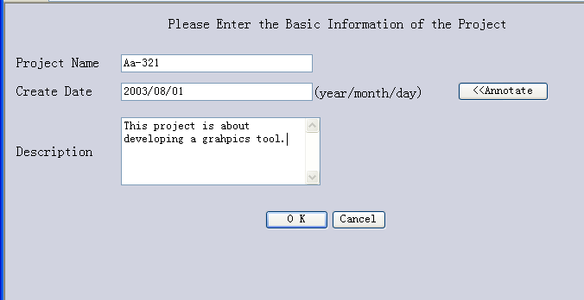
This input situation is similar to specific bug’s basic information, role’s basic information.
Let’s take the role specification as another example, here we should make use of component ‘list/menu bar’ and ‘group radio’ to complete our input:
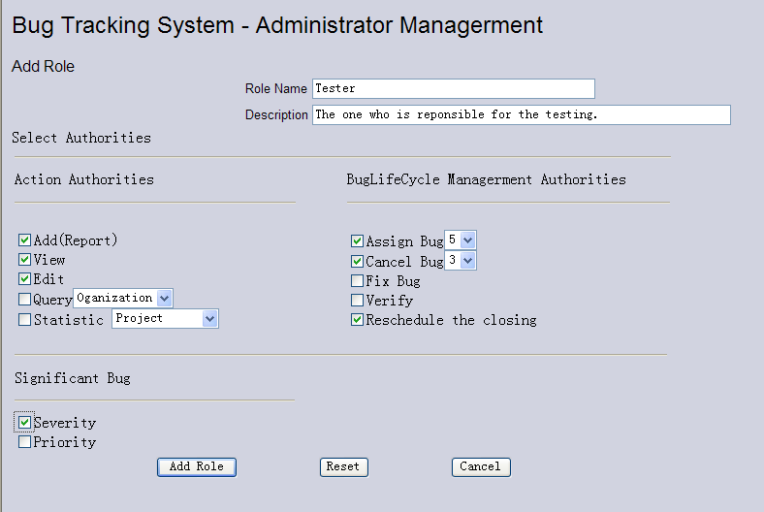
We select the group radio and select the list bar in the form. This input is similar to bug specification and query and statistic. In these input situations, user will input the date or select the items as input method.

4.3Output

4.3.1Output Data Background
The main output background is as below:
- Situation:
  - Project List:
The admin is responsible for manage projects’ information. He can create, edit, or close a project. Every time he logs on to BTS, BTS will show him a list of existing projects. He can choose a project to edit or close, or can he create a new project. All these 3 works will update the database. After admin has done this update, the BTS will display updated projects list that is the output of project management.
  - Role List
The situation of role list is similar to that of project list. When admin creates a project or edits a project, he should define the roles in the project. While he management the roles, BTS will show him a list of roles. He can select a role to edit or create a new role. After any modification, BTS will update the database and display updated role list.
  - Bug List
When tester or programmer or PM logs on to BTS, a list of bugs will be displayed to him. He can choose a bug that is assigned to him to edit. Tester can report a new bug. Any modification will make the database update. Then BTS will display the latest bug list to user.
  - Result of querying bugs
PM or tester or programmer may face a lot of bugs displayed to him, at this time, he can execute query and eliminate the number of displayed bugs. At the time of querying, user input the query requirements and submit them to BTS, BTS then searches the database. The qualified records will be output and showed to user.
  - Result of statistic bugs
PM or tester or programmer may want a statistic after a period of time in order to have a better knowledge of project. He select the statistic requirements and submit them to BTS, BTS then searches the relative records. After the qualified records have been found, BTS calculate the records and draw graph results.
- Situation Frequency
  - Project List:
The output occurs at the time admin logs on or the time admin executes updating a project.
  - Role List
When admin creates a new project or edits a existing project, the role list will be displayed to him. Every time he modifies a role, he can see the updated role list,
  - Bug List
Every time user logs on to BTS, he can see the bug list assigned to him.
  - Result of querying bugs
Every time user wants to querying bugs, he submits the querying requirements to BTS. After BTS searching qualified records, the output occurs.
  - Result of statistic bugs
When user wants to have a bug statistic, he submits the statistic requirements to BTS. BTS finds the matched records and calculate them. At this time, the output occurs.
- Output medium
All the output is through the screen so that user can see it directly. If user wants to print it, the output can be typed through printer and showed in paper. User can also save the output the store medium like hardware, disk or CD-R.
- Quality management
Before the output occurs, BTS checks the data. If there is exception, the output stops, the error information will be returned to user. This method prevents the system from fatal errors, so that BTS can decrease the possibilities of giving user error information.
- Dominate
The statistic and query data result will be temporary saved while user visits BTS. After they log out the result will not be saved.
The project list, role list and bug list will be saved even when the BTS is power off because of these three lists are determined by database.

4.3.2Output Format
BTS has some confine for output format:
- Beginning part:
Beginning part shall have the basic information of output or some operation component. Take project list and role list for example:
    - Project List
The beginning part contains several operation buttons, including ‘create project’ button, ‘edit’ button and so on. User can select one button to operate the output.
    - Role List
The beginning part is composed of project information. The info includes the project name, project id, creation date and project description.
- Main part
The main part is generally a table. It shows all the qualified items and some important attributes of items. Each row represents a record and each column represents a attribute.
- Ending part
Most outputs do not have ending part. We may have some implement details in ending, including copyright, warming info or the operation components the same as the beginning part.

4.3.3Instance For Output
The output is in the form of table, one row stands for a project or a role or a bug or a result.
That’s take an instance for output:
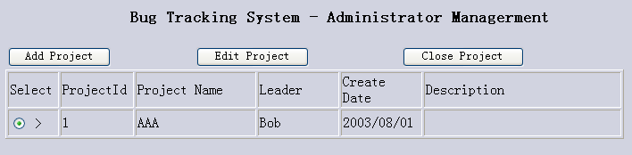
See the picture, it is output of project list. Each row represents a project. If we want to operate a project, we can select the radio in the first column.
Other output forms is the same as this form.

4.4Query Document
BTS has capacity of querying:
- Query Bugs:
The programmer, tester or PM may want to view some bugs, at this time, they will use query subsystems. They fill a form of query condition. In this form, user select query condition as the page shows. After user submits the form, BTS starts to search the qualified bug items. BTS translates the input to SQL language and send it to database, then the database searches the records according to SQL language.
- Statistic Bugs:
Statistic Bugs is somewhere similar to query bugs, but more complex. User inputs the statistic conditions to BTS and BTS submits them to database. After database finishing the search work, it returns the information to BTS, then BTS complete the statistic works and shows them to users.
- Create Project/ Edit Project
When admin creates project or edits project, he probably will use the external system—Stuff Information System. Once he needs to use external system, BTS will automatic execute the query language. BTS will search all the stuff information and user information, and compare them. After that, BTS will shows admin all the stuffs BTS does not have.

4.5Exception Management
BTS will come to exception while running. The exception conditions are listed as below:
- The user input error data that BTS can’t find, while BTS execute them, exceptions come out. In order to ensure the system can continue running, BTS will return error information to user and require user to input again.
- If the database cannot be connected, information will be returned to user. User may choose to connect again or give up operation.
- If accidents (e.g. Power is off, Computer is broken) occur when user are inputting or system is calculating, the system will return to the last saved environment. If the input data isn’t been submitted, it won’t be saved.
- If the client side doesn’t install the java environment or the web browse tool doesn’t support JavaScript, user can’t run BTS correctly. BTS may have info to warm user install the relative tools.

4.6Terminal Operations
BTS is a distribute software. It adopts B/S architecture. The server provides all the service to client PCs. All the client PCs shall do is connect to the server and interact with server. The client PC should use web browser, entering the server’s IP and connect the server web site
Users sent all the commands through net. The server responses the commands and executes them. Then the results are returned to users also through net.
Because of our software have high security level, the user cannot visit the database directly. User can only interact with the web pages. The tasks are done by BTS automatically and they are invisible to users.

5. Conclusion
Omitted.

